Chapter-3 A brief History of fractals
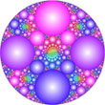
3.1 Introduction

The word "Fractal" was coined in 1975 by Benoit Mandelbrot(1924 - ) to describe shapes which are detailed at all scales. A fractal is a never-ending pattern. Many Fractals are infinitely complex patterns that are self-similar across different scales. They are created by repeating a simple process over and over in an ongoing feedback loop. Driven by recursion, fractals are images of dynamic systems - the pictures of Chaos. The word is a variant of "fractional", since a fractal is a type of fractional dimension images of many naturally occuring physical phenomena. Its Latin root is "fractus", suggesting fragmented, broken and discontinuous. As a result, the word "fractal" is now used not only for objects with fractional dimension, but also for those with the property of repeating self-similar shapes even when they do not have a characteristic of fractional dimesion.
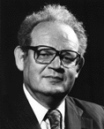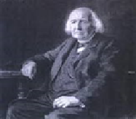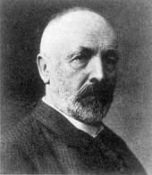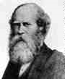
Figures 3.1 Mandelbrot Karl Weierstrass Georg Cantor Henry Smith
3.2 History of evolution of fractal concept
The first mathematical fractal was discovered in 1861 by Karl Weierstrass(1815 - 1897).
Weierstrass's function was, although continuous, completely made of corners, and nowhere differentiable. It was not possible to define the rate of change anywhere.
This was a shock to the scientists of the day, and it was named "pathological curve".
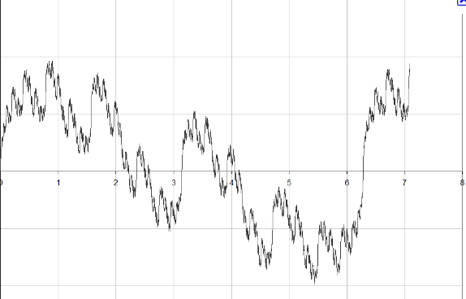
Figure 3.2 A Weirstrass curve.
The Cantor Set,which is now named after the German mathematician Georg Cantor(1845 - 1918), the student of Weierstrass, is one of the first fractals to be studied mathematically. It was the year 1883. But this was actually discovered by Henry Smith(1826 - 1883), a professor of geometry at Oxford , in 1875. The Cantor set has no length, and in mathematical terms,it has "zero measure". But how about its dimension ? Mathematicians began searching for a new way of defining dimension and came up witth the concept of fractal dimension.
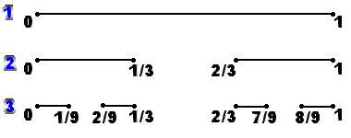
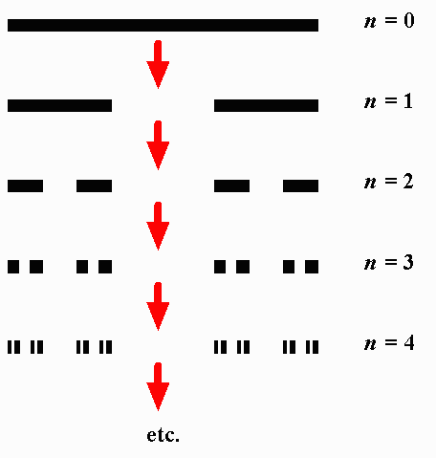
Figure 3.3 Two views of construction of Canter set (or dust)
Around 1890, an Italian mathemtician Giuseppe Peano(1858 - 1932) surprised the mathematical world by dicovering what was called "space-filling curve". His curve was constructed in such a way that there was no point on the plane that its twisted curve would not include. It means that a line, which is considered as one dimensional object, has one to one mapping to all the points on the plane, which is two dimensional.
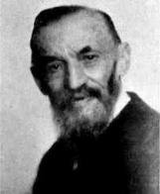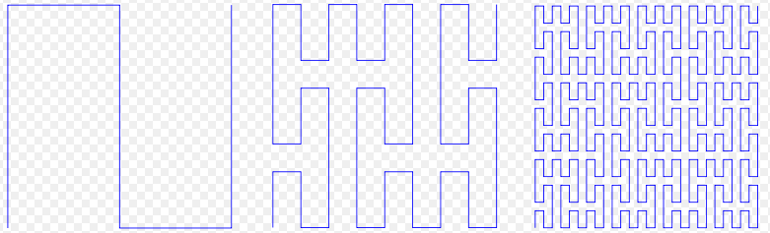
Figure 3.4 Giuseppe Peano Three iterations of Peano Space filling curves

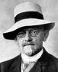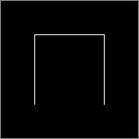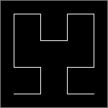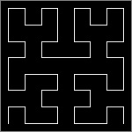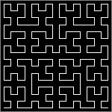
Figure 3.5 D Hillbert and Four iterations of Hilbert Space filling curves
The other "pathological" curve was discovered in 1904 by a Swedish mathematician Helge von Koch(1870 - 1924). The finished curve,though contained in a finite area, has an infinite length ,
and has no smoothness, or tangent anywhere. It is now called Koch's snowflake or simply Koch curve. What he did not know was that its property of infinite length can be used as an ideal model for the shapes of the real world like coastlines, and its dimension was later found being equal to (log 4)/(log 3) = 1.26... (it is fractal !!).
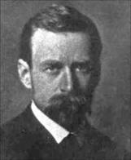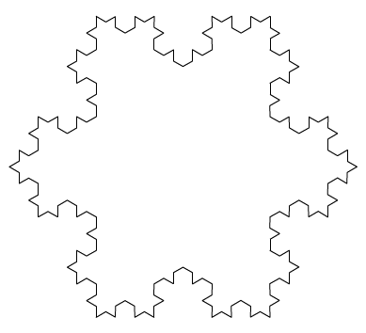
Figure 3.6 Helge von Koch Koch’s snow flake
In 1916, the polish mathematician Waclaw Sierpinski(1882 - 1969) introduced a fractal now called "Sierpinski Gasket" or "Sierpinski Triangle". Nowadays this fractal model figure can be seen in almost any books writtten about the topic of fractal.
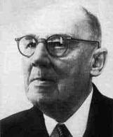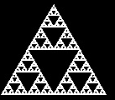
Figure 3.7 Waclaw Sierpinski Sierpinski Triangle
During the late 19-th and early 20-th entury, another group of mathematicians began research on what is now called "dynamical system", by iterating simple functions. In 1979,British mathematician Sir Arthur Cayley(1821 - 1895) published a problem called "Newton-Fourier Imaginary Problem", in which he proposed a new method of finding roots of algebraic equation using Newton's method in complex plane. He wrote at the end of his one page article :
" The solution is easy and elegant in the case of a quadric equation , but the next succeeding case of the cubic equation appears to present considerable difficulty.", and the paper on the cubic equation case has never been published by him. The reader will soon see the reason why it is so.
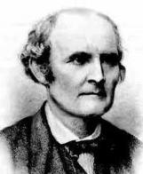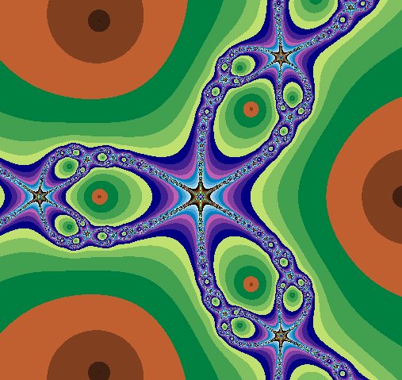
Figure 3.8 Sir Arthur Cayley Newton Fractal
This paper motivated the French mathematician Gaston Julia(1893 - 1978) and his compatriot and competitor Pierre Fatou (1878 - 1929) to do reseach in area of complex iteration.
In 1918,when Julia was only 25 years old, Julia published his 199 page masterpiece Mémoire sur l'itération des fonctions rationnelles, (concerning the iteration of a rational function) . It received the Grand Prix de l'Académie des Sciences.
Although he was famous in the 1920s, his work was essentially forgotten until Benoit Mandelbrot brought it back to prominence in the 1970s through his fundamental computer experiments.
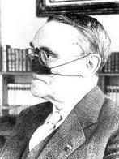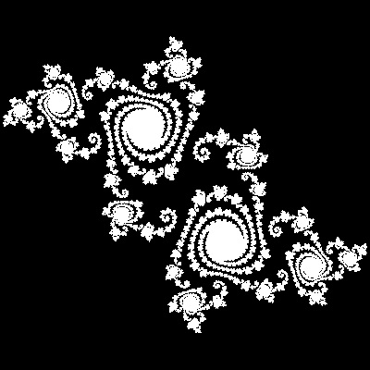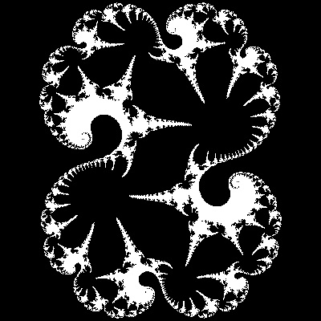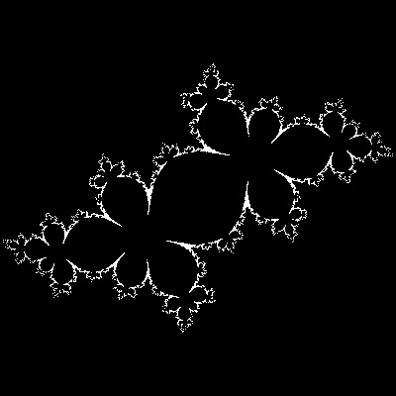
Figure 3.9 Gaston Julia and Julia sets
"Julia Set" and "Fatou set" are named after these two early reserchers to honor their great contributions.
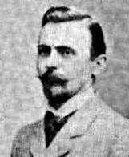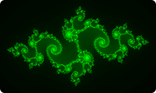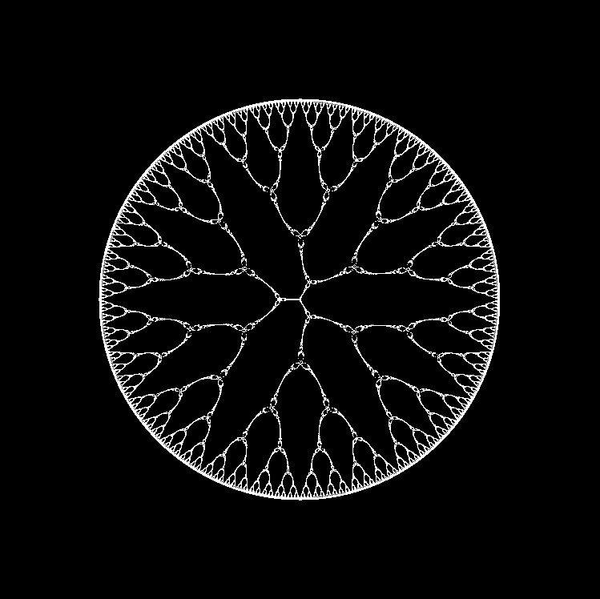
Figure 3.10 Pierre Fatou and Fatou sets
Aristid Lindenmayer(1925-1989) in 1968 introduced a mathematical formalism called L-systems for modelling growth of plants. . Central to L-systems, is the notion of rewriting, where the basic idea is to define complex objects by successively replacing parts of a simple object using a set of rewriting rules or productions. More recently, L-systems have found several applications in computer graphics that include generation of fractals and realistic modelling of plants. The rewriting can be carried out recursively. The most extensively studied and the best understood rewriting systems operate on character strings.
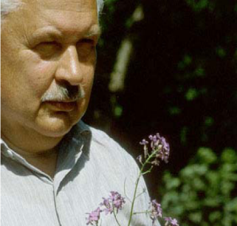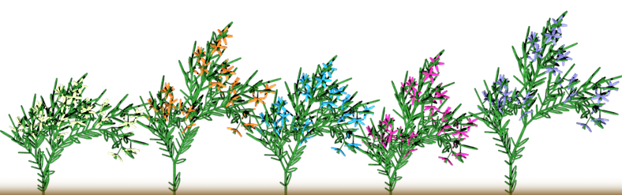
Figure 3.11 Aristid Lindenmayer , Plants generated by Lindermayer system
In 1980 Benoit Madelbrot discovered "Mandelbrot Set" while he was experimenting with Julia Set using high speed computers. Since then many mathematicians joined the bandwagon ,and many words like Chaos, Dynamical System, Fractal, etc has become the household names.
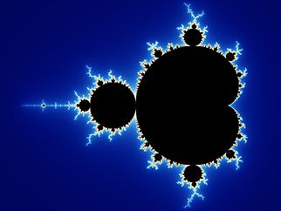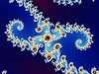
Figure 3.12 Full Mandelbrot set and two expansions of its boundary
At the same period , Michael Barnsley developed IFS (Iterated Function systems) Fractals . This system has the ability to create realistic images with very small sets of numbers. The idea is also used for Image compression.

Figure 3.13 Michal Barnsly Barnsley’s Fern Fractal
Currently Fractals on its own is a branch of mathematics which has found applications in all areas of science and technology.
3.3 Fractals –Indian roots
3.3.1 Kolams
A kolam is a design decorating the courtyards of homes in the villages of southern India. Perhaps five millennia old, these art forms are described in many ancient Sanskrit texts. The designs can cover areas up to 3 meters by 3 meters. Occasionally they consist of small patterns repeated many times, but more often they are small drawings connected in very sophisticated ways.
Here are two examples, the Anklets of Krishna and the snake. Some typical kolam figures are also shown.

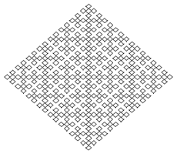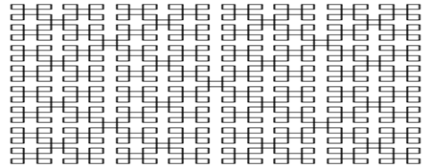
Figure 3.14 Anklets of Krishna and the snake

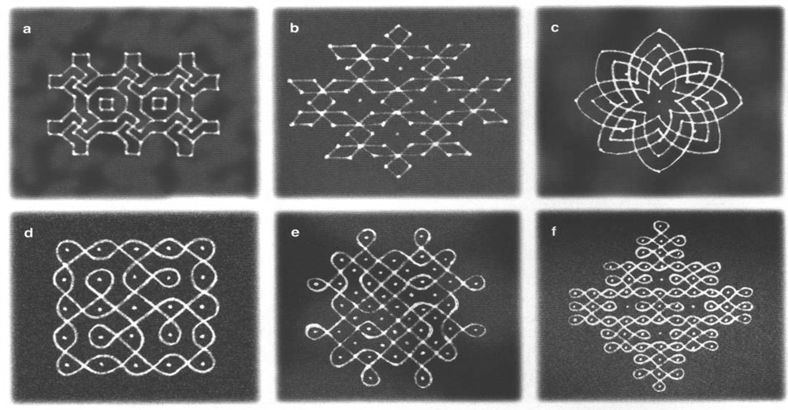
Figure 3.15 Typical Kolams (Floor decorations in front of the house) of South India
3.3.2 Fractals in Indian Architecture
Indian and Southeast Asian temples and monuments exhibit a fractal structure: a tower surrounded by smaller towers, surrounded by still smaller towers, and so on, for eight or more levels. Quoting William Jackson,
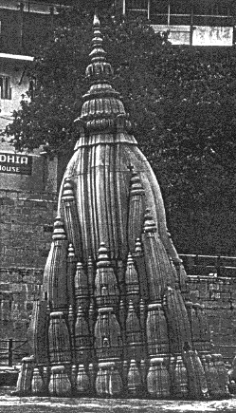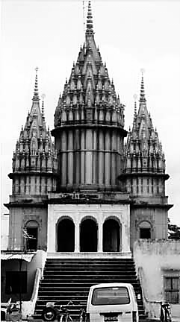

"The ideal form gracefully artificed suggests the infinite rising levels of existence and consciousness, expanding sizes rising toward transcendence above, and at the same time housing the sacred deep within."
Jackson goes on to assert that the whole religious vision of Hinduism has a fractal character:
"This universe is like a ripe fruit appearing from the activity of the cit [consciousness]. There is a branch of a tree bearing innumerable such fruit. There is a tree having thousands of such branches. There is a forest with thousands of such trees. There is a mountainous territory having thousands of such forests. There is a territory containing thousands of such territories. There is a solar system containing thousands of such territories. There is a universe containing thousands of such solar systems. And there are many such universes contained within what is like an atom within an atom. This is what is known as cit or the subtle sun which illumines everything in the world. All the things of the world take their rise in it. Amidst all this incessant activity, the cit is ever in undisturbed repose."
So perhaps the fractal aspects of Hindu architecture reflect the fractal nature of Hindu cosmology.
3.3.3 Fractals for school kids : Mathematics of Fractal Geometry
This is a new area in math. Let our students know that math is still developing, that it is a living subject. Most of mathematics we teach in school is old knowledge. For example, the geometry we study about circles, squares, and triangles was organized around 300 B.C. by a man named Euclid. Much of fractal geometry, however, is newer. Research on fractals is being carried out even right now by mathematicians. Engineers are finding newer applications like Fractal antennae based on fractal geometry (your own mobile phones are using one). Economists are using it for time series analysis.
One important aspect of fractal geometry is that some part of it is understandable to anybody and the geometry /picture it generates are stunningly beautiful. It poses problems at all levels of mathematical mastery. An innocent child as well as an established mathematician finds fractal interesting as well as challenging.
We must tell them this is University Math . They love this, it makes them feel special, it also lets them know that there is a whole new exciting world of math out there waiting for them when they leave school. We must explain how fractal geometry can be applied to the real world. Math is not only beautiful, it is useful.
3.4 References
[1] Ascher, M. The Kolam Tradition. American Scientist. 90(1). pp. 56. 2002.
[2] Prusinkiewicz, P., K. Krithivasan and M. G. Vijayanarayana. 1989. Application of L-systems to algorithmic generation of South India folk art patterns and Karnatic music, in A Perspective in Computer Science:
[3] Jackson, W., Heaven's Fractal Net. Retrieving Lost Visions in the Humanities, Indiana Univ. Pr. 2004.
Fracal applications http://library.thinkquest.org/26242/full/ap/ap.html
3.5 Websites
Juia and Fatou set http://www.ijon.de/mathe/julia/some_julia_sets_1_en.html
http://fractalfoundation.org/OFC/OFC-index.htm
IFS Fractals http://www.hiddendimension.com/FractalMath/IFS_Fractals_Main.html
Types of fractals http://www.miqel.com/fractals_math_patterns/visual_math_fractal_types.html
Application of fractals http://www.miqel.com/fractals_math_patterns/fractal_technology_historical.html


